**REVIEW -1**

**Geometric shapes: Its area and applications**.

Name: Tithi Shah

Reg.No.: 23BCE0809

**1. Home Page**

* **Content**:
  + Welcome message
  + Quotes related to geometric shapes and stating their importance
  + Navigation links to other pages
* **Design**:
  + 4 card structures for quotes
  + Buttons for "Sign In" or "Registration”

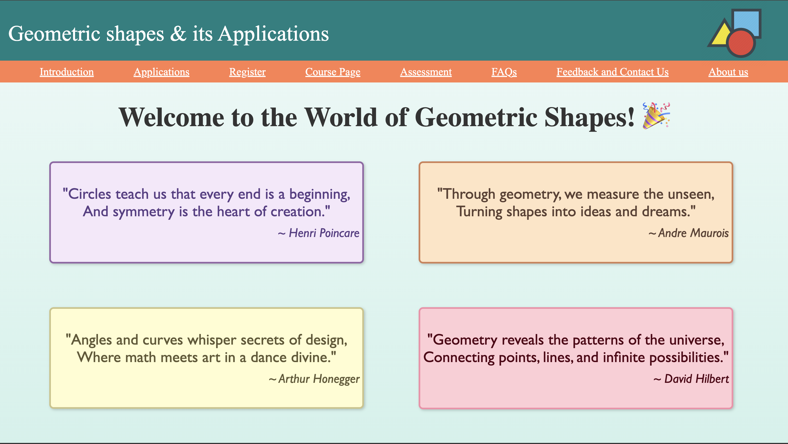

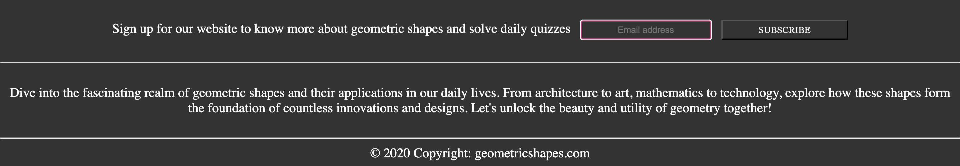

HTML code:  
<!DOCTYPE html>

<html lang="en">

<head>

<meta charset="UTF-8">

<meta name="viewport" content="width=device-width, initial-scale=1.0">

<title>Home Page</title>

<link rel="stylesheet" href="HomePage.css">

</head>

<body>

<div class="navbar2">

Geometric shapes & its Applications

<div class="logo"></div>

</div>

<div class="smallnavbar">

<div class="h"><a href="Introduction.html" class="m">Introduction</a></div>

<div class="h"><a href="Applications.html" class="m">Applications</a></div>

<div class="h"><a href="Registration.html" class="m">Register</a></div>

<div class="h"><a href="IC.html" class="m">Course Page</a></div>

<div class="h"><a href="AssessmentStart.html" class="m">Assessment</a></div>

<div class="h"><a href="faqs.html" class="m">FAQs</a></div>

<div class="h"><a href="feedback.html" class="m">Feedback and Contact Us</a></div>

<div class="h"><a href="AboutUs.html" class="m">About us</a></div>

</div>

<div class="main">

<div class="msg">

Welcome to the World of Geometric Shapes! 🎉

</div>

<div class="quotes">

<div class="q1">

<div class="quote1">

"Circles teach us that every end is a beginning,<br/>

And symmetry is the heart of creation." <br/>

<div class="author"><i>~ Henri Poincare</i></div>

</div>

<div class="quote2">

"Through geometry, we measure the unseen,<br/>

Turning shapes into ideas and dreams."<br/><div class="author"><i>~ Andre Maurois</i></div>

</div>

</div>

<div class="q2">

<div class="quote3">

"Angles and curves whisper secrets of design,<br/>

Where math meets art in a dance divine."<br/><div class="author"><i>~ Arthur Honegger</i></div>

</div>

<div class="quote4">

"Geometry reveals the patterns of the universe,<br/>

Connecting points, lines, and infinite possibilities."<br/><div class="author"><i>~ David Hilbert</i></div>

</div>

</div>

</div>

<div class="intro">

</div>

</div>

<div class="footer">

<div class="first">

Sign up for our website to know more about geometric shapes and solve daily quizzes

<input placeholder="Email address" class="input"> <a href="Registration.html"><button class="reg">SUBSCRIBE</button></a>

</div>

<br/><hr/><br/>

Dive into the fascinating realm of geometric shapes and their applications

in our daily lives. From architecture to art, mathematics to technology,

explore how these shapes form the foundation of countless innovations and designs.

Let's unlock the beauty and utility of geometry together!<br/><br/><hr/>

<div class="lastline">

© 2020 Copyright: geometricshapes.com

</div>

</div>

</body>

</html>

CSS code:  
body {

margin: 0;

padding: 0;

}

.m{

color:white;

}

.navbar2 {

background-color: #008080;

height: 100px;

width: 1425px;

font-size: 40px;

color: white;

font-family:'Times New Roman', Times, serif;

padding-left: 15px;

padding-top: 10px;

display: flex;

align-items: center;

}

.logo{

height:120px;

width:120px;

background-image: url("logo1.png");

background-size: cover;

margin-left: 680px;

}

.smallnavbar {

background-color: #FF7F50;

height: 40px;

width: 1440px;

font-size: 20px;

color:white;

font-family:'Times New Roman', Times, serif;

display: flex;

align-items: center;

justify-content: space-evenly;

}

.smallnavbar :hover {

font-weight: bolder;

text-decoration: underline;

}

.main{

background: linear-gradient(to bottom, #e8f8f5, #d1f2eb);

height: 660px;

width: 1440px;

}

.msg {

color: #333333;

font-weight: 900;

font-size: 50px;

text-align: center;

padding-top: 30px;

}

.msg:hover {

text-transform: uppercase;

}

.q1{

margin-top: 9px;

display: flex;

justify-content:space-between;

}

.q2{

display: flex;

justify-content:space-between;

}

.quote1{

font-size:28px;

font-family:'Gill Sans', 'Gill Sans MT', Calibri, 'Trebuchet MS', sans-serif;

border-width: 3px;

border-radius: 8px;

border-style:solid;

border-color: #9466A6;

width: 600px;

text-align: center;

margin-left:90px;

margin-top: 40px;

margin-bottom: 40px;

padding-top: 40px;

padding-bottom: 40px;

background-color: #f5e8fa;

color: #5A3E85;

box-shadow: 2px 2px 5px rgba(0, 0, 0, 0.2);

}

.quote2{

font-size:28px;

font-family:'Gill Sans', 'Gill Sans MT', Calibri, 'Trebuchet MS', sans-serif;

border-width: 3px;

border-radius: 8px;

border-style:solid;

border-color: #D08057;

width: 600px;

text-align: center;

margin-left:100px;

margin-right: 100px;

margin-top: 40px;

margin-bottom: 40px;

padding-top: 40px;

padding-bottom: 40px;

background-color: #ffe4c4;

color: #5C4033;

box-shadow: 2px 2px 5px rgba(0, 0, 0, 0.2);

}

.quote3 {

font-size:28px;

font-family:'Gill Sans', 'Gill Sans MT', Calibri, 'Trebuchet MS', sans-serif;

border-width: 3px;

border-radius: 8px;

border-style:solid;

border-color: rgb(203, 196, 136);

width: 600px;

text-align: center;

margin-left:90px;

margin-top: 40px;

margin-bottom: 40px;

padding-top: 40px;

padding-bottom: 40px;

background-color: #fffdd0;

color: #615834;

height:100px;

box-shadow: 2px 2px 5px rgba(0, 0, 0, 0.2);

}

.quote4 {

font-size:28px;

font-family:'Gill Sans', 'Gill Sans MT', Calibri, 'Trebuchet MS', sans-serif;

border-width: 3px;

border-radius: 8px;

border-style:solid;

border-color: rgb(245, 143, 169);

width: 600px;

text-align: center;

margin-left:100px;

margin-right: 100px;

margin-top: 40px;

margin-bottom: 40px;

padding-top: 40px;

padding-bottom: 40px;

background-color: rgb(255, 205, 214);

color: rgb(82, 0, 20);

box-shadow: 2px 2px 5px rgba(0, 0, 0, 0.2);

}

.author {

text-align: right;

text-align: end;

font-size: smaller;

padding-right: 5px;

padding-top: 10px;

}

.intro {

color: #333333;

font-size: 23px;

margin-top: 0px;

padding-left: 10px;

padding-right: 10px;

}

.footer{

background-color: #333333;

height:220px;

color:white;

padding-top: 30px;

text-align: center;

font-size: 20px;

}

.input {

border-radius: 2px;

border-width: 1px;

height: 25px;

width:190px;

text-align: center;

background-color: #333333;

border-color: white;

color: white;

border-style: solid;

margin-left: 10px;

margin-right: 10px;

}

.reg {

height: 30px;

width: 190px;

text-align: center;

background-color: #333333;

color: white;

font-family:Cambria, Cochin, Georgia, Times, 'Times New Roman', serif

}

**2. About Us (Company Profile)**

* **Content**:
  + Overview of the project
  + Objectives of the website (e.g., educate, assess, inspire)
* **Design**:
  + Two-column layout with text on one side and an image/graphic on the other.

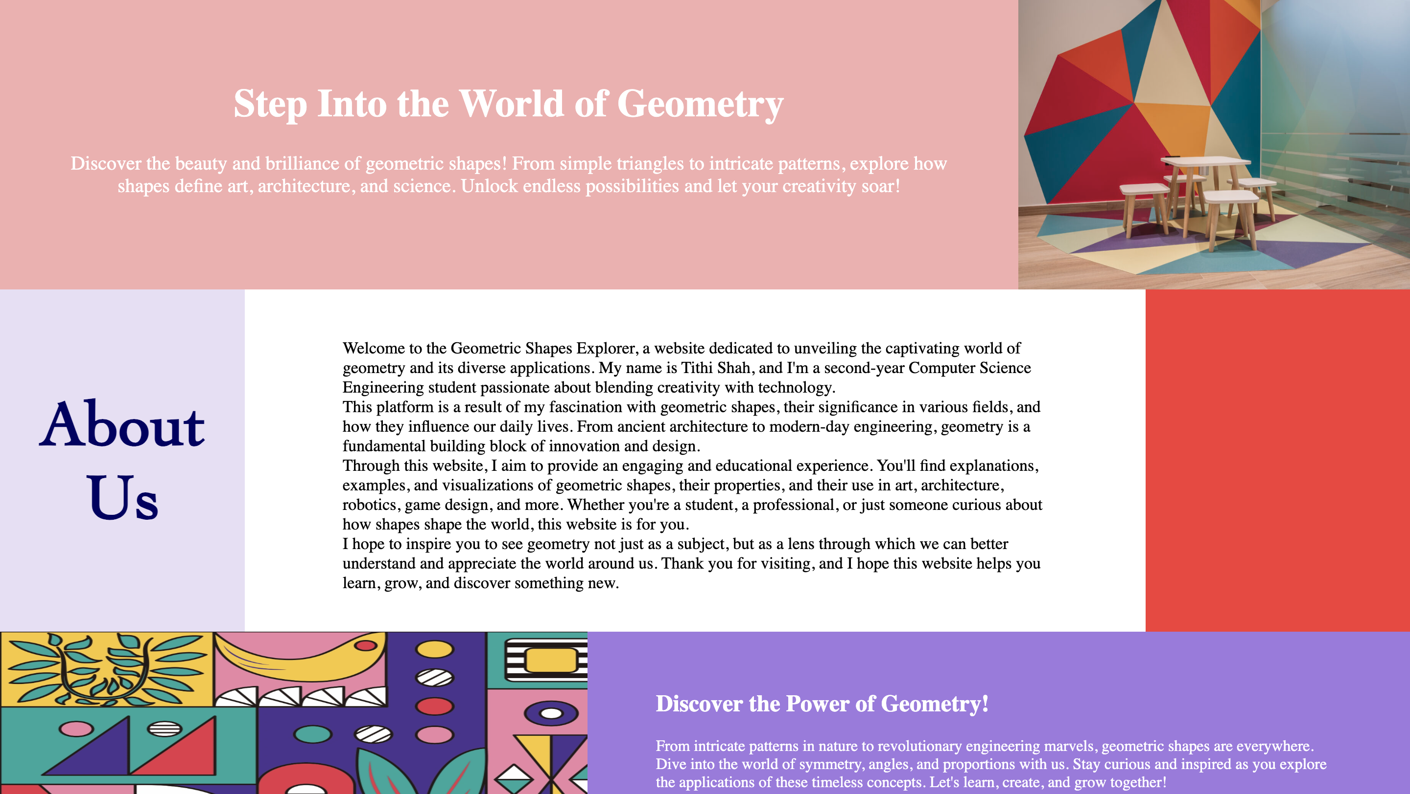

HTML code:  
<!DOCTYPE html>

<html lang="en">

<head>

<meta charset="UTF-8">

<meta name="viewport" content="width=device-width, initial-scale=1.0">

<title>About Us</title>

<link rel="stylesheet" href="AboutUs.css">

</head>

<body>

<div class="line1">

<div class="one"><h1>Step Into the World of Geometry</h1>

Discover the beauty and brilliance of geometric shapes! From simple triangles to intricate patterns, explore how shapes define art, architecture, and science. Unlock endless possibilities and let your creativity soar!</div>

<div class="img1"><img src="img3.png" height="300px" width="400px"/></div>

</div>

<div class="line2">

<div class="two">About<br/>Us</div>

<div class="three">Welcome to the Geometric Shapes Explorer, a website dedicated to unveiling the captivating world of geometry and its diverse applications. My name is Tithi Shah, and I'm a second-year Computer Science Engineering student passionate about blending creativity with technology.

<br/>This platform is a result of my fascination with geometric shapes, their significance in various fields, and how they influence our daily lives. From ancient architecture to modern-day engineering, geometry is a fundamental building block of innovation and design.

<br/>Through this website, I aim to provide an engaging and educational experience. You'll find explanations, examples, and visualizations of geometric shapes, their properties, and their use in art, architecture, robotics, game design, and more.

Whether you're a student, a professional, or just someone curious about how shapes shape the world, this website is for you.

<br/>I hope to inspire you to see geometry not just as a subject, but as a lens through which we can better understand and appreciate the world around us.

Thank you for visiting, and I hope this website helps you learn, grow, and discover something new.</div>

<div class="four"></div>

</div>

<div class="line3">

<div class="img2"><img src="img.png" width="600px" height="210px"/></div>

<div class="five"><h2>Discover the Power of Geometry!</h2>

From intricate patterns in nature to revolutionary engineering marvels, geometric shapes are everywhere. Dive into the world of symmetry, angles, and proportions with us. Stay curious and inspired as you explore the applications of these timeless concepts. Let's learn, create, and grow together!</div>

</div>

</body>

<footer style="text-align: center; margin-top: 3px; font-size: 14px; color: #666;">

© 2025 geometricshapes.com. All Rights Reserved.

</footer>

</html>

CSS code:

body{

margin: 0;

}

.line1{

width:1440px;

height: 300px;

display: flex;

}

.one{

width:1000px;

height:240px;

padding-top: 60px;

background-color: rgb(245, 174, 174);

color:white;

text-align: center;

font-size: 20px;

padding-left: 50px;

padding-right: 50px;

}

.line2{

width:1440px;

height: 350px;

display: flex;

}

.two{

width:250px;

height:250px;

padding-top: 100px;

background-color: #E8DFF5;

text-align: center;

font-weight: 520;

font-size: 65px;

color:rgb(1, 1, 99);

font-family:Cambria, Cochin, Georgia, Times, 'Times New Roman', serif;

}

.three{

background-color: white;

width:720px;

height:250px;

font-size:17px;

padding-top:50px;

padding-bottom:50px;

padding-left:100px;

padding-right: 100px;

}

.four{

width:270px;

height:350px;

background-color: rgb(249, 55, 55);

}

.line3{

height:210px;

width:1440px;

display: flex;

}

.five{

height:170px;

width:700px;

background-color: rgb(159, 121, 224);

color: white;

padding-left:70px;

padding-right: 70px;

padding-top: 40px;

}

**3. Introduction to Geometry**

* **Content**:
  + Definition of geometry
  + Historical background
  + Real-world relevance
* **Design**:
  + Timeline representation for historical details.
  + Interactive sections for real-world applications (e.g., architecture, engineering).

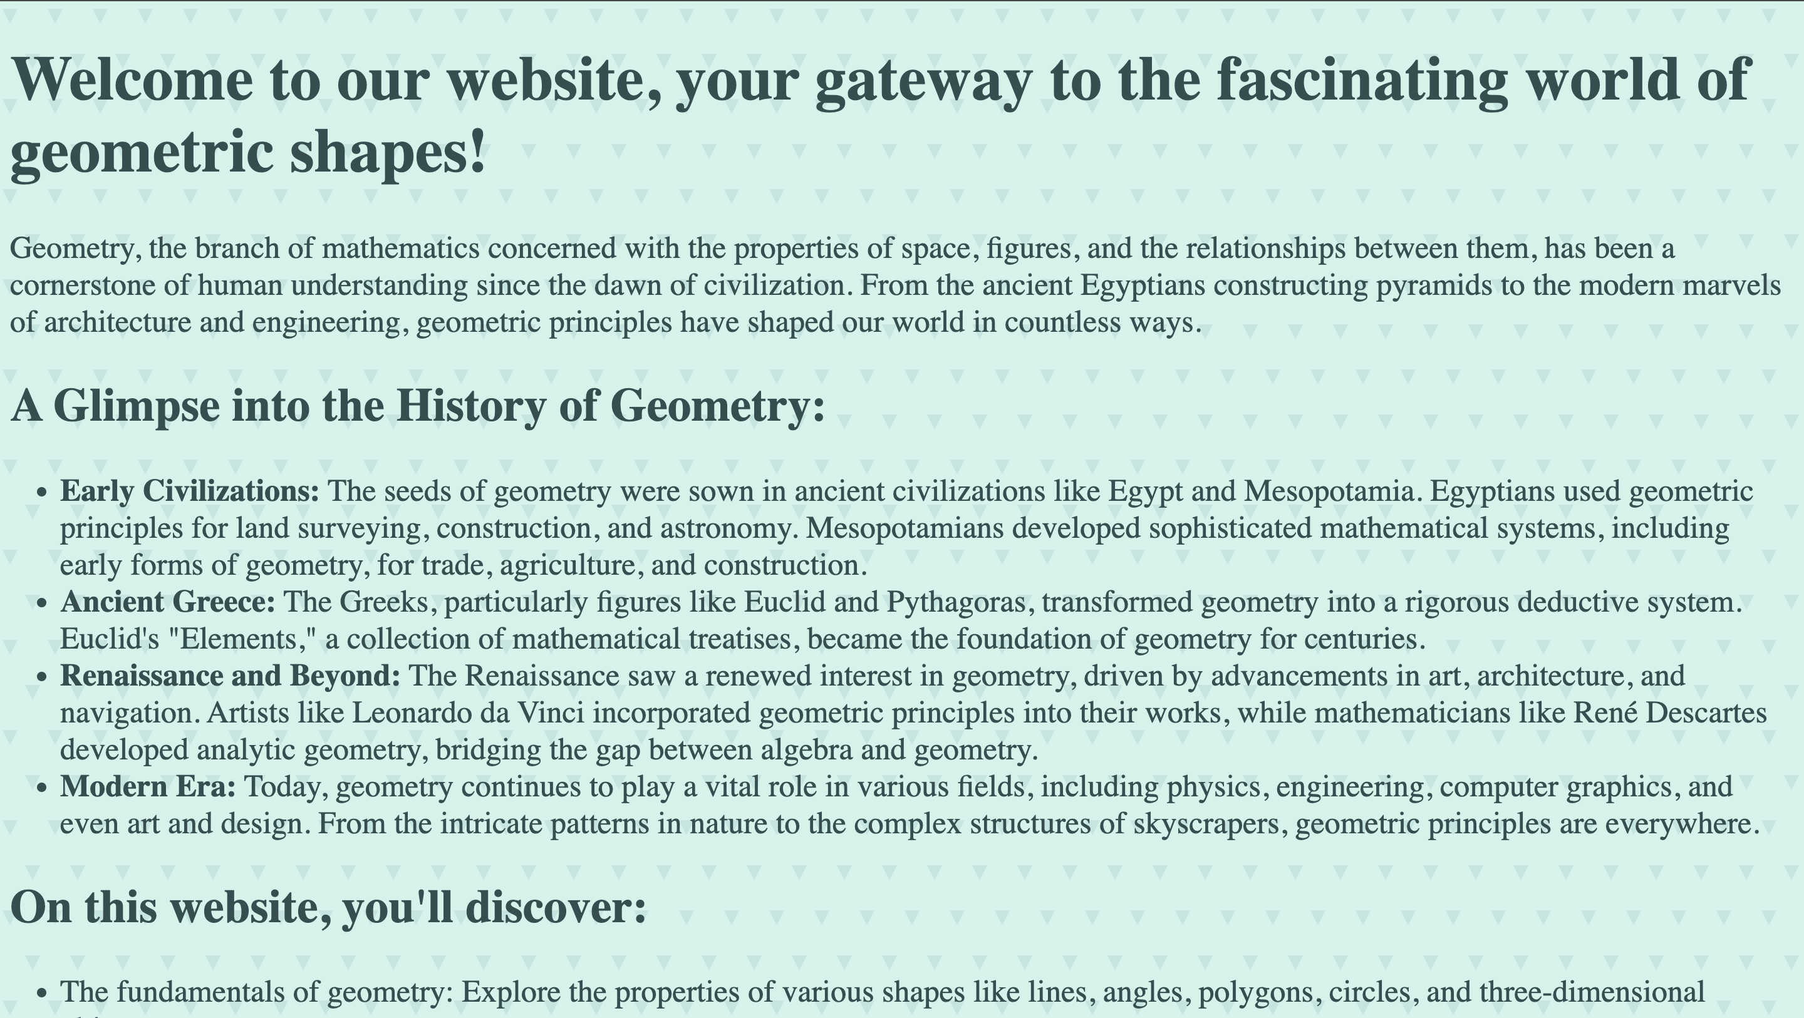



HTML code:

<!DOCTYPE html>

<html lang="en">

<head>

<meta charset="UTF-8">

<meta name="viewport" content="width=device-width, initial-scale=1.0">

<title>Introduction Page</title>

<link rel="stylesheet" href="Introduction.css">

</head>

<body>

<h1>Welcome to our website, your gateway to the fascinating world of geometric shapes!</h1>

<p>Geometry, the branch of mathematics concerned with the properties of space, figures, and the relationships between them, has been a cornerstone of human understanding since the dawn of civilization. From the ancient Egyptians constructing pyramids to the modern marvels of architecture and engineering, geometric principles have shaped our world in countless ways.</p>

<h2>A Glimpse into the History of Geometry:</h2>

<ul>

<li><strong>Early Civilizations:</strong> The seeds of geometry were sown in ancient civilizations like Egypt and Mesopotamia. Egyptians used geometric principles for land surveying, construction, and astronomy. Mesopotamians developed sophisticated mathematical systems, including early forms of geometry, for trade, agriculture, and construction.</li>

<li><strong>Ancient Greece:</strong> The Greeks, particularly figures like Euclid and Pythagoras, transformed geometry into a rigorous deductive system. Euclid's "Elements," a collection of mathematical treatises, became the foundation of geometry for centuries.</li>

<li><strong>Renaissance and Beyond:</strong> The Renaissance saw a renewed interest in geometry, driven by advancements in art, architecture, and navigation. Artists like Leonardo da Vinci incorporated geometric principles into their works, while mathematicians like René Descartes developed analytic geometry, bridging the gap between algebra and geometry.</li>

<li><strong>Modern Era:</strong> Today, geometry continues to play a vital role in various fields, including physics, engineering, computer graphics, and even art and design. From the intricate patterns in nature to the complex structures of skyscrapers, geometric principles are everywhere.</li>

</ul>

<h2>On this website, you'll discover:</h2>

<ul>

<li>The fundamentals of geometry: Explore the properties of various shapes like lines, angles, polygons, circles, and three-dimensional objects.</li>

<li>Real-world applications: Learn how geometric concepts are applied in fields like architecture, engineering, art, and technology.</li>

<li>Interactive tools and resources: Engage with interactive exercises, simulations, and visualizations to deepen your understanding of geometry.</li>

<li>A timeline of geometric discoveries: Trace the evolution of geometric thought from ancient civilizations to the present day.</li>

</ul>

<p>And much more!</p>

<p>Whether you're a student, a curious learner, or simply someone who appreciates the beauty and elegance of geometry, we invite you to explore this website and embark on a journey of discovery.</p>

<h2>Let's unlock the secrets of shapes together!</h2>

<div class="buttons">

<a href="https://byjus.com/maths/2d-shapes/" target="_blank"><button class="c">Click here to know more about 2D shapes</button></a>

<a href="https://byjus.com/maths/3d-shapes/" target="_blank"><button class="c">Click here to know more about 3D shapes</button></a></div>

</body>

<footer style="text-align: center; margin-top: 10px; font-size: 14px; color: #666;">

© 2025 geometricshapes.com. All Rights Reserved.

</footer>

</html>

CSS code:

body{

font-size:25px;

color:darkslategray;

background-color: #d1f2eb;

background-image: url("data:image/svg+xml,%3Csvg xmlns='http://www.w3.org/2000/svg' width='36' height='72' viewBox='0 0 36 72'%3E%3Cg fill-rule='evenodd'%3E%3Cg fill='%23008080' fill-opacity='0.10'%3E%3Cpath d='M2 6h12L8 18 2 6zm18 36h12l-6 12-6-12z'/%3E%3C/g%3E%3C/g%3E%3C/svg%3E");

}

.buttons{

display:flex;

justify-content: space-evenly;

height:50px;

}

.c{

border-radius: 8px;

border-color:darkcyan;

background-color: darkcyan;

height:50px;

width:650px;

font-size:20px;

color:white;

font-weight: 700;

}

.c:hover{

background-color: rgb(0, 52, 52);

border-color:rgb(0, 52, 52);

}

**4-6. Shape Pages (3 pages)**

Anchor tag redirecting to each shape in detail:

* **2D Shapes**: Circle, triangle, square, etc.
* **3D Shapes**: Sphere, cube, cylinder, etc.
* **Content**:
  + Description of each shape
  + Formulas for area, perimeter, and volume

**7. Applications of Geometry**

* **Content**:
  + Applications in architecture, design, robotics, etc.
  + Case studies or examples
* **Design**:
  + Grid layout with each application represented visually.

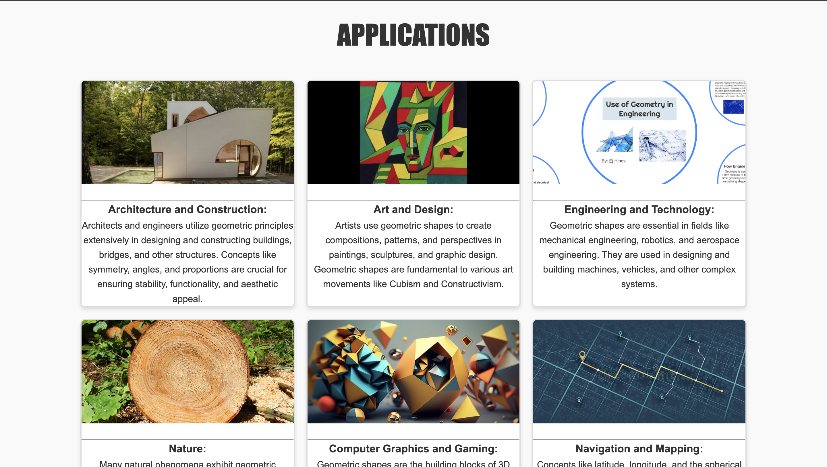

HTML code:

<!DOCTYPE html>

<html lang="en">

<head>

<meta charset="UTF-8">

<meta name="viewport" content="width=device-width, initial-scale=1.0">

<title>Applications</title>

<link rel="stylesheet" href="Applications.css">

</head>

<body>

<header>

<h1>APPLICATIONS</h1>

</header>

<main class="grid-container">

<div class="application-card">

<img src="arch.png" alt="Application 1" class="app-image">

<p class="app-description"><hr/><h3>Architecture and Construction:</h3>

Architects and engineers utilize geometric principles extensively in designing and constructing buildings, bridges, and other structures.

Concepts like symmetry, angles, and proportions are crucial for ensuring stability, functionality, and aesthetic appeal.</p>

</div>

<div class="application-card">

<img src="art.png" alt="Application 2" class="app-image">

<p class="app-description"><hr/><h3>Art and Design:</h3>

Artists use geometric shapes to create compositions, patterns, and perspectives in paintings, sculptures, and graphic design.

Geometric shapes are fundamental to various art movements like Cubism and Constructivism.</p>

</div>

<div class="application-card">

<img src="eng.png" alt="Application 3" class="app-image">

<p class="app-description"><hr/><h3>Engineering and Technology:</h3>

Geometric shapes are essential in fields like mechanical engineering, robotics, and aerospace engineering.

They are used in designing and building machines, vehicles, and other complex systems.</p>

</div>

<div class="application-card">

<img src="nature.png" alt="Application 4" class="app-image">

<p class="app-description"><hr/><h3>Nature:</h3>

Many natural phenomena exhibit geometric patterns.

For example, snowflakes have intricate hexagonal shapes, while honeycombs are made up of perfectly arranged hexagons.

Understanding these geometric patterns can help us understand the natural world better.</p>

</div>

<div class="application-card">

<img src="gra.png" alt="Application 5" class="app-image">

<p class="app-description"><hr/><h3>Computer Graphics and Gaming:</h3>

Geometric shapes are the building blocks of 3D models and computer graphics.

They are used to create realistic and immersive environments in video games and virtual reality experiences.</p>

</div>

<div class="application-card">

<img src="map.png" alt="Application 6" class="app-image">

<p class="app-description"><hr/><h3>Navigation and Mapping:</h3>

Concepts like latitude, longitude, and the spherical shape of the Earth are fundamental to navigation and mapmaking.

Geometric principles are used to determine locations, distances, and directions.</p>

</div>

</main>

</body>

<footer style="text-align: center; margin-top: 3px; font-size: 14px; color: #666;">

© 2025 geometricshapes.com. All Rights Reserved.

</footer>

</html>

CSS code:

* {

margin: 0;

padding: 0;

box-sizing: border-box;

}

body {

font-family: Arial, sans-serif;

background-color: #f9f9f9;

color: #333;

line-height: 1.6;

}

header h1 {

font-family: Impact, sans-serif;

font-size: 3rem;

text-align: center;

margin: 20px 0;

color: #333;

text-transform: uppercase;

}

.grid-container {

display: grid;

grid-template-columns: repeat(3, 1fr);

gap: 20px;

max-width: 1200px;

margin: 0 auto;

padding: 20px;

}

.application-card {

background-color: #fff;

border: 2px solid #ddd;

border-radius: 8px;

overflow: hidden;

box-shadow: 0 4px 6px rgba(0, 0, 0, 0.1);

text-align: center;

transition: transform 0.3s ease, box-shadow 0.3s ease;

}

.application-card:hover {

transform: translateY(-5px);

box-shadow: 0 6px 12px rgba(0, 0, 0, 0.2);

}

.app-image {

width: 100%;

height: 180px;

object-fit: cover;

}

.app-description {

padding: 10px;

font-size: 1rem;

color: #555;

}

**8. Interactive Course Page**

* **Content**:
  + Lessons on understanding and calculating areas and volumes.
  + Examples and exercises.
* **Design**:
  + Step-by-step answers.

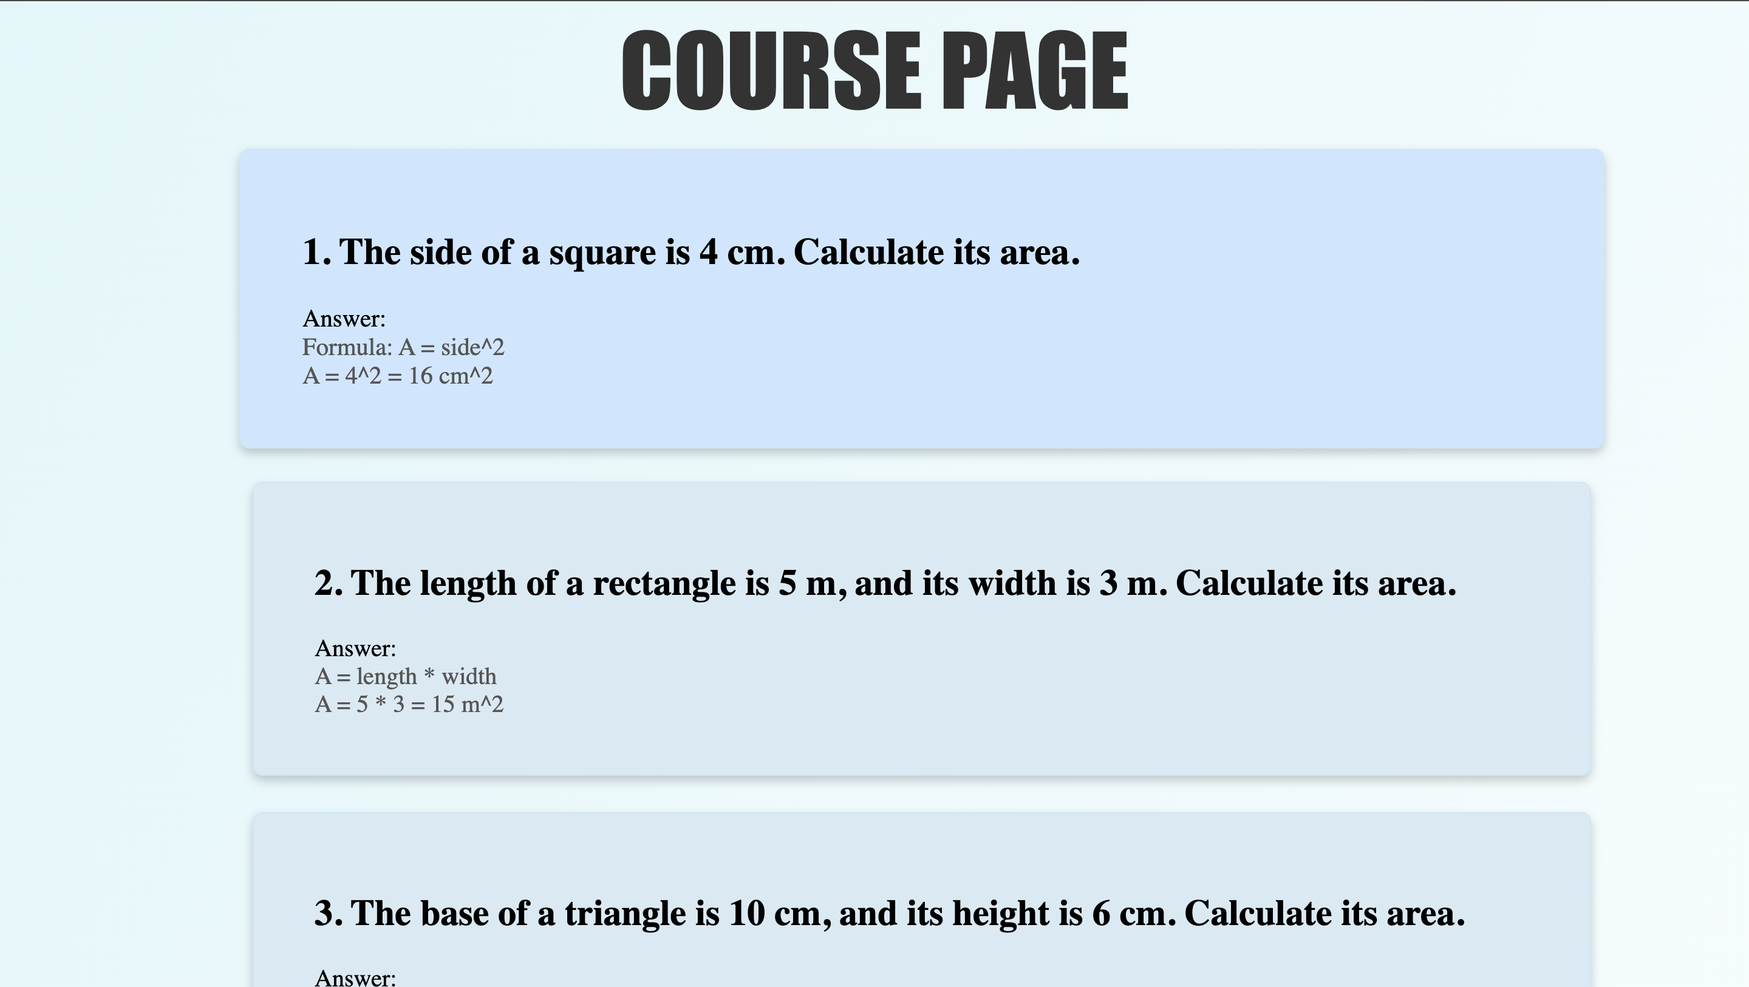

HTML code:

<!DOCTYPE html>

<html lang="en">

<head>

<meta charset="UTF-8">

<meta name="viewport" content="width=device-width, initial-scale=1.0">

<title>Course Page</title>

<link rel="stylesheet" href="IC.css">

</head>

<body>

<div class="head">COURSE PAGE</div><br/>

<div class="eg">

<h2>1. The side of a square is 4 cm. Calculate its area.</h2>

Answer: <br/>

<div class="ans">

Formula: A = side^2<br/>

A = 4^2 = 16 cm^2

</div>

</div>

<div class="eg">

<h2>2. The length of a rectangle is 5 m, and its width is 3 m. Calculate its area.</h2>

Answer: <br/>

<div class="ans">

A = length * width<br/>

A = 5 * 3 = 15 m^2

</div>

</div>

<div class="eg">

<h2>3. The base of a triangle is 10 cm, and its height is 6 cm. Calculate its area.</h2>

Answer: <br/>

<div class="ans">

A = 1/2 * base * height<br/>

A = 1/2 * 10 * 6 = 30 cm^2

</div>

</div>

<div class="eg">

<h2>4. The radius of a circle is 7 m. Calculate its area.</h2>

Answer: <br/>

<div class="ans">

A = 3.1416 * radius^2<br/>

A = 3.1416 * 7^2 = 153.94 m^2

</div>

</div>

<div class="eg">

<h2>5. The radius of a sphere is 5 cm. Calculate its volume.</h2>

Answer: <br/>

<div class="ans">

V = 4/3 * 3.1416 * radius^3<br/>

V = 4/3 * 3.1416 * 5^3 = 523.6 cm^3

</div>

</div>

<div class="eg">

<h2>6. The base area of a cylinder is 28 cm², and its height is 10 cm. Calculate its

volume.</h2>

Answer: <br/>

<div class="ans">

V = base area * height<br/>

V = 28 * 10 = 280 cm^3

</div>

</div>

<div class="eg">

<h2>7. The side of a cube is 3 m. Calculate its volume.</h2>

Answer: <br/>

<div class="ans">

Formula: V = side^3<br/>

V = 3^3 = 27 m^3

</div>

</div>

<div class="eg">

<h2>8. The radius of a cone is 4 cm, and its height is 9 cm. Calculate its volume.</h2>

Answer: <br/>

<div class="ans">

Formula: V = 1/3 * 3.1416 * radius^2 * height<br/>

V = 1/3 * 3.1416 * 4^2 * 9 = 150.8 cm^3

</div>

</div>

<div class="eg">

<h2>9. The diagonal of a square is 10 cm. Calculate its area.</h2>

Answer: <br/>

<div class="ans">

Formula: A = diagonal^2 / 2<br/>

A = 10^2 / 2 = 50 cm^2

</div>

</div>

<div class="eg">

<h2>10. The length of a cuboid is 8 m, width is 4 m, and height is 5 m. Calculate its

volume.</h2>

Answer: <br/>

<div class="ans">

Formula: V = length * width * height<br/>

V = 8 * 4 * 5 = 160 m^3

</div>

</div>

</body>

<footer style="text-align: center; margin-top: 30px; font-size: 14px; color: #666;">

© 2025 geometricshapes.com. All Rights Reserved.

</footer>

</html>

CSS code:

body{

background:linear-gradient(to bottom right, #e0f7fa, #ffffff);

}

.head{

font-size:80px;

font-family:Impact, Haettenschweiler, 'Arial Narrow Bold', sans-serif;

text-align: center;

color:#333333;

}

.eg{

border-radius: 8px;

border-color: #d7eaf3;

box-shadow: 0 4px 8px rgba(0, 0, 0, 0.2);

background-color: #d7eaf3;

width:1000px;

height:200px;

margin-left:200px;

padding-top:40px;

margin-bottom: 30px;

padding-left:50px;

padding-right:50px;

font-size:20px;

border: 1px solid #cae7f5;

}

.ans{

color:#555555;

}

.eg:hover{

background-color: #cce7ff;

transform: scale(1.02);

}

**9-18. Assessment Page**

* **Content**:
  + Multiple-choice questions
* **Design**:
  + Results displayed dynamically.

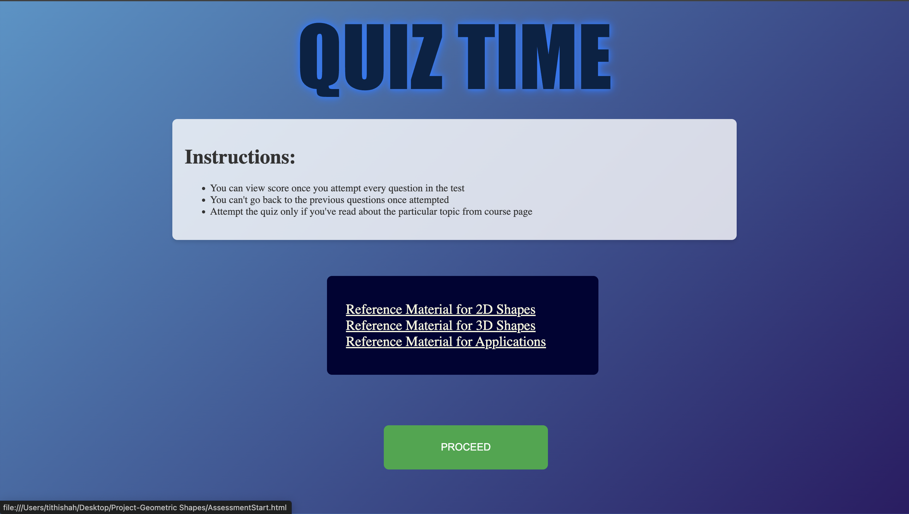

HTML code:

<!DOCTYPE html>

<html lang="en">

<head>

<meta charset="UTF-8">

<meta name="viewport" content="width=device-width, initial-scale=1.0">

<title>Quiz</title>

<link rel="stylesheet" href="AssessmentStart.css">

</head>

<body>

<div class="head">QUIZ TIME</div>

<div class="inst">

<h1>Instructions:</h1>

<ul>

<li>You can view score once you attempt every question in the test</li>

<li>You can't go back to the previous questions once attempted</li>

<li>Attempt the quiz only if you've read about the particular topic from course page</li>

</ul>

</div><br/><br/>

<div class="topics">

<a href="https://byjus.com/maths/2d-shapes/" target="_blank" class="top">Reference Material for 2D Shapes</a><br/>

<a href="https://byjus.com/maths/3d-shapes/" target="_blank" class="top">Reference Material for 3D Shapes</a><br/>

<a href="https://www.geeksforgeeks.org/applications-of-geometry/" target="_blank" class="top">Reference Material for Applications</a>

</div>

<a href="AssessmentQ1.html"><button class="btn">PROCEED</button></a>

</body>

</html>

CSS code:

body {

background: linear-gradient(135deg, #4995c9, #2c1c65);

}

.head{

font-size:130px;

font-family:Impact, Haettenschweiler, 'Arial Narrow Bold', sans-serif;

text-align: center;

color: #032345;

text-shadow: 0 0 8px #007BFF, 0 0 16px #007BFF;

}

.inst{

background: rgba(255, 255, 255, 0.8);

padding: 20px;

border-radius: 8px;

box-shadow: 0px 4px 6px rgba(0, 0, 0, 0.1);

margin: 20px auto;

max-width: 60%;

color: #333;

}

.topics{

display: inline-block;

margin-left:510px;

width:400px;

padding-left: 30px;

padding-top:40px;

padding-bottom: 40px;

background: #000334;

color: white;

border-radius: 8px;

font-size:22px;

}

.top{

color:beige;

}

.top:hover{

background: #0056b3;

}

.btn{

font-size:30px;

margin-top: 80px;

margin-left: 600px;

margin-bottom:62px;

height:70px;

width: 260px;

background-color: #28a745;

color: white;

font-size: 16px;

border: none;

padding: 12px 24px;

border-radius: 8px;

cursor: pointer;

transition: transform 0.2s, background-color 0.3s;

}

.btn:hover {

background-color: #218838;

transform: scale(1.05);

}

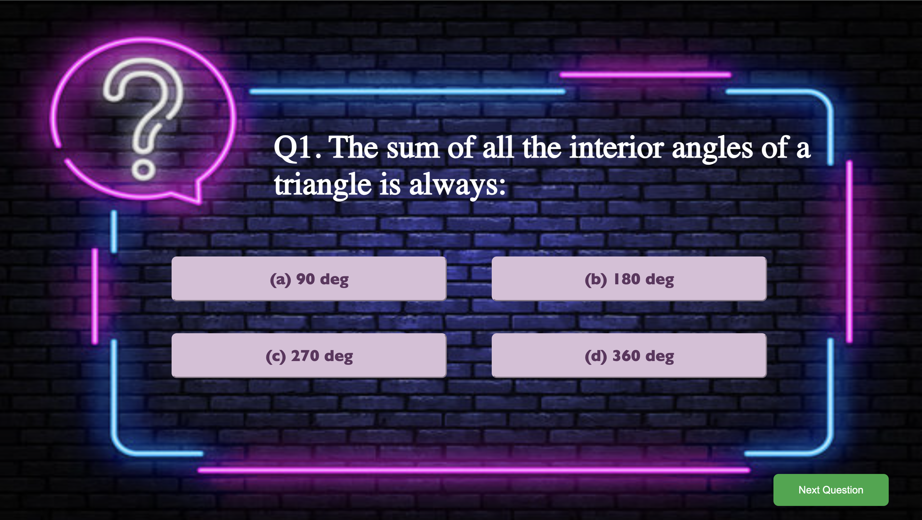

HTML code:

<!DOCTYPE html>

<html lang="en">

<head>

<meta charset="UTF-8">

<meta name="viewport" content="width=device-width, initial-scale=1.0">

<title>Q1</title>

<link rel="stylesheet" href="AssessmentQ1.css">

</head>

<body>

<div class="main">

Q1. The sum of all the interior angles of a triangle is always:<br/><br/><br/>

</div>

<div class="options">

<div class="line1">

<button class="opt">(a) 90 deg</button>

<button class="opt">(b) 180 deg</button>

</div>

<div class="line2">

<button class="opt">(c) 270 deg</button>

<button class="opt">(d) 360 deg</button>

</div>

</div>

<a href="AssessmentQ2.html">

<button class="next">

Next Question

</button></a>

</body>

</html>

CSS code:

body{

background: url("quiz.png");

background-size: 1440px 830px;

}

.main{

color:white;

font-size:50px;

font-weight: 550;

margin-left:420px;

margin-top:200px;

width:900px;

height:200px;

}

.line1{

display: flex;

margin-bottom: 50px;

}

.line2{

display: flex;

}

.options{

margin-left:260px;

width:1000px;

height:300px;

}

.opt{

width:500px;

height:70px;

margin-right: 70px;

background-color:thistle;

border-radius: 8px;

border-color:thistle;

font-size:25px;

color:rgb(95, 53, 95);

font-family:'Gill Sans', 'Gill Sans MT', Calibri, 'Trebuchet MS', sans-serif;

font-weight: 700;

}

.opt:hover{

background-color: rgb(55, 22, 55);

color:beige;

border-color: rgb(55, 22, 55);

}

.next{

margin-top:40px;

margin-left:1200px;

height:50px;

width: 180px;

text-align: center;

text-decoration: none;

background-color: #28a745;

color: white;

font-size: 16px;

border: none;

padding: 12px 24px;

border-radius: 8px;

cursor: pointer;

transition: transform 0.2s, background-color 0.3s;

}

.next:hover{

background-color: #218838;

transform: scale(1.05);

}

**19. Feedback and Contact Us Page**

* **Content**:
  + Feedback form
  + Contact details (email, social media, etc.)
* **Design**:
  + Clean and simple form layout.

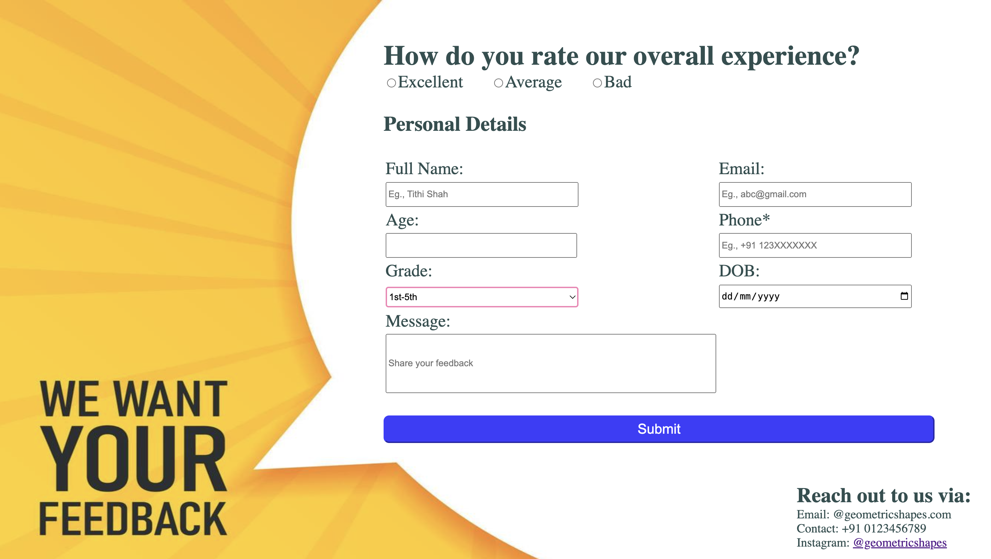

HTML code:

<!DOCTYPE html>

<html lang="en">

<head>

<meta charset="UTF-8">

<meta name="viewport" content="width=device-width, initial-scale=1.0">

<title>Feedback & Contact us</title>

<link href="feedback.css" rel="stylesheet">

</head>

<body>

<div class="main">

<div class="head">How do you rate our overall experience?</div>

<div class="options">

<div class="opt"><input type="radio" name="exc" value="excellent"/>Excellent</div>

<div class="opt"><input type="radio" name="avg" value="avg"/>Average</div>

<div class="opt"><input type="radio" name="bad" value="bad"/>Bad</div>

</div><br/>

<div class="head2">Personal Details</div><br/>

<table>

<tr>

<td> Full Name:</td>

<td>Email:</td>

</tr>

<tr>

<td><input type="text" placeholder="Eg., Tithi Shah" size="40px" style="height: 30px;"/></td>

<td><input type="email" placeholder="Eg., abc@gmail.com" size="40px" style="height: 30px;"/></td>

</tr>

<tr>

<td>Age:</td>

<td>Phone*</td>

</tr>

<tr>

<td><input type="number" size="40px" style="height: 30px; width:270px;"/></td>

<td><input type="tel" placeholder="Eg., +91 123XXXXXXX" size="40px" style="height: 30px;"/></td>

</tr>

<tr>

<td>Grade:</td>

<td>DOB:</td>

</tr>

<tr>

<td>

<select name="select" style="height: 30px;width:280px;">

<option value="1-5">1st-5th</option>

<option value="6-8">6th-8th</option>

<option value="9-10">9th-10th</option>

<option value="11-12">11th-12th</option>

<option value="ug">UG</option>

</select>

</td>

<td>

<input type="date" size="40px" style="height: 30px;width:275px;"/>

</td>

</tr>

<tr>

<td>Message:</td>

</tr>

<tr>

<td>

<input type="text" placeholder="Share your feedback" size="70px" style="height: 80px; "/>

</td>

</tr>

</table><br/>

<button class="btn">Submit</button><br/><br/><br/>

<div class="contact">

<div class="head2">Reach out to us via:</div>

<div class="con">

Email: @geometricshapes.com<br/>

Contact: +91 0123456789<br/>

Instagram: <a href="">@geometricshapes</a>

</div>

</div>

</div>

</body>

</html>

CSS code:

body {

background-image: url("bg2.jpg");

background-size: 1440px 830px;

}

.main{

width:870px;

height:650px;

margin-left: 550px;

font-size: 25px;

padding-top: 50px;

color:darkslategray;

}

.head{

font-size: 40px;

color:darkslategray;

font-weight: 600;

}

.head2{

font-size: 30px;

color:darkslategray;

font-weight: 600;

}

.options{

display: flex;

}

.opt{

margin-right:40px;

color:darkslategray;

}

.btn{

width:800px;

height:40px;

font-size: 20px;

background-color: rgb(61, 61, 253);

color: white;

text-align: center;

border-radius: 8px;

border-color: rgb(61, 61, 253);

}

.con{

font-size: 18px;

}

.contact{

margin-left: 600px;

}

**20. Course Registration Page**

* **Content**:
  + Form for users to sign up for geometry lessons
* **Design**:
  + User-friendly form with validations and confirmation messages.

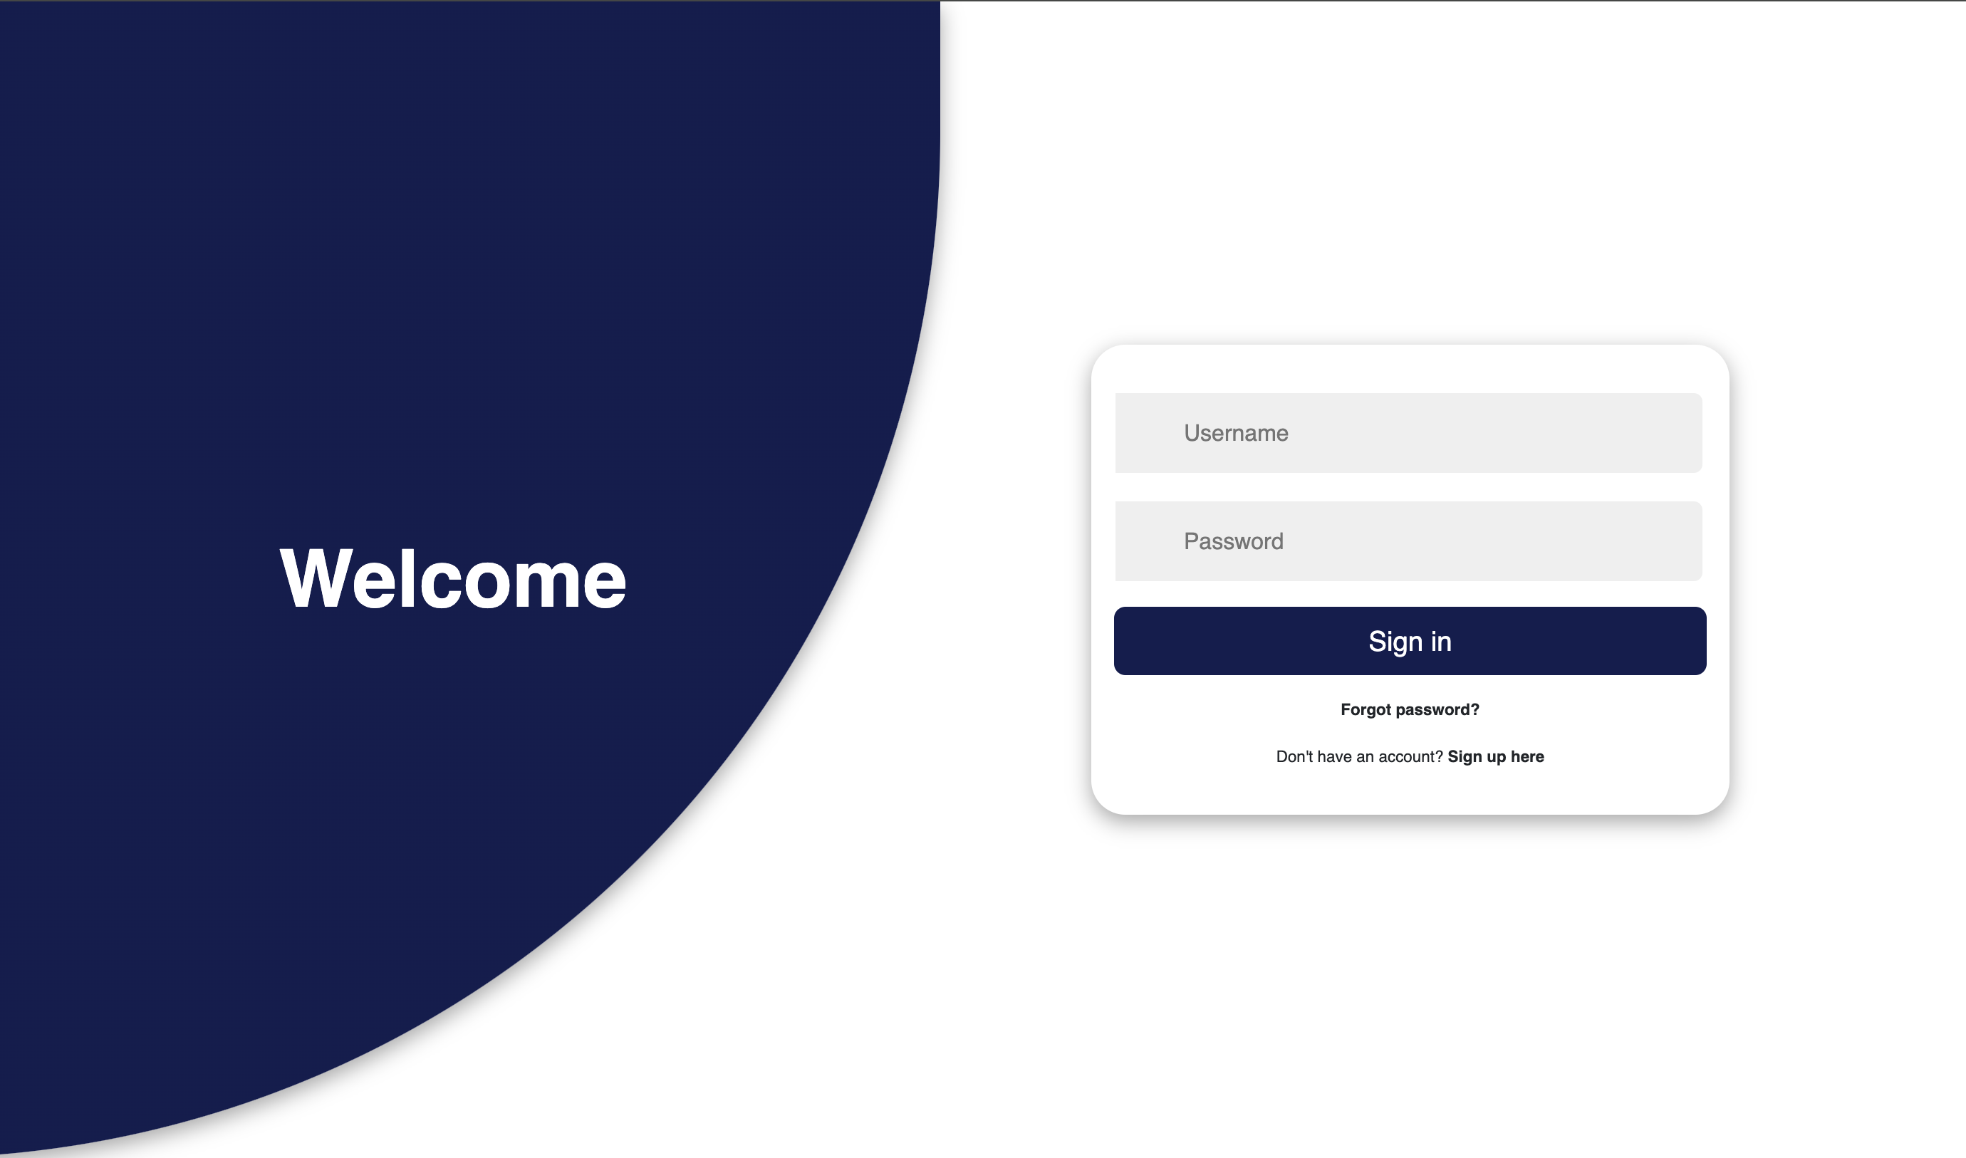



HTML code:

<!DOCTYPE html>

<html lang="en">

<head>

<meta charset="UTF-8">

<meta name="viewport" content="width=device-width, initial-scale=1.0">

<title>Sign-in</title>

<link href="https://cdn.jsdelivr.net/npm/bootstrap@5.3.3/dist/css/bootstrap.min.css" rel="stylesheet">

<link rel="stylesheet" href="Registration.css">

<script src="registration.js" defer></script>

</head>

<body>

<div id="container" class="container">

<div class="row">

<div class="col align-items-center flex-col sign-up">

<div class="form-wrapper align-items-center">

<div class="form sign-up">

<div class="input-group">

<i class='bx bxs-user'></i>

<input type="text" placeholder="Username">

</div>

<div class="input-group">

<i class='bx bx-mail-send'></i>

<input type="email" placeholder="Email">

</div>

<div class="input-group">

<i class='bx bxs-lock-alt'></i>

<input type="password" placeholder="Password">

</div>

<div class="input-group">

<i class='bx bxs-lock-alt'></i>

<input type="password" placeholder="Confirm password">

</div>

<button>

Sign up

</button>

<p>

<span>

Already have an account?

</span>

<b onclick="toggle()" class="pointer">

Sign in here

</b>

</p>

</div>

</div>

</div>

<div class="col align-items-center flex-col sign-in">

<div class="form-wrapper align-items-center">

<div class="form sign-in">

<div class="input-group">

<i class='bx bxs-user'></i>

<input type="text" placeholder="Username">

</div>

<div class="input-group">

<i class='bx bxs-lock-alt'></i>

<input type="password" placeholder="Password">

</div>

<button>

Sign in

</button>

<p>

<b>

Forgot password?

</b>

</p>

<p>

<span>

Don't have an account?

</span>

<b onclick="toggle()" class="pointer">

Sign up here

</b>

</p>

</div>

</div>

<div class="form-wrapper">

</div>

</div>

</div>

<div class="row content-row">

<div class="col align-items-center flex-col">

<div class="text sign-in">

<h2>

Welcome

</h2>

</div>

<div class="img sign-in">

</div>

</div>

<div class="col align-items-center flex-col">

<div class="img sign-up">

</div>

<div class="text sign-up">

<h2>

Join with us

</h2>

</div>

</div>

</div>

</div>

</body>

</html>

CSS code:

:root {

--primary-color: #131d4f;

--secondary-color: #131d4f;

--black: #000000;

--white: #ffffff;

--gray: #efefef;

--gray-2: #757575;

--facebook-color: #4267B2;

--google-color: #DB4437;

--twitter-color: #1DA1F2;

--insta-color: #E1306C;

}

@import url('https://fonts.googleapis.com/css2?family=Poppins:wght@200;300;400;500;600&display=swap');

* {

font-family: 'Poppins', sans-serif;

margin: 0;

padding: 0;

box-sizing: border-box;

}

html,

body {

height: 100vh;

overflow: hidden;

}

.container {

position: relative;

min-height: 100vh;

overflow: hidden;

}

.row {

display: flex;

flex-wrap: wrap;

height: 100vh;

}

.col {

width: 50%;

}

.align-items-center {

display: flex;

align-items: center;

justify-content: center;

text-align: center;

}

.form-wrapper {

width: 100%;

max-width: 28rem;

}

.form {

padding: 1rem;

background-color: var(--white);

border-radius: 1.5rem;

width: 100%;

box-shadow: rgba(0, 0, 0, 0.35) 0px 5px 15px;

transform: scale(0);

transition: .5s ease-in-out;

transition-delay: 1s;

}

.input-group {

position: relative;

width: 100%;

margin: 1rem 0;

}

.input-group i {

position: absolute;

top: 50%;

left: 1rem;

transform: translateY(-50%);

font-size: 1.4rem;

color: var(--gray-2);

}

.input-group input {

width: 100%;

padding: 1rem 3rem;

font-size: 1rem;

background-color: var(--gray);

border-radius: .5rem;

border: 0.125rem solid var(--white);

outline: none;

}

.input-group input:focus {

border: 0.125rem solid var(--primary-color);

}

.form button {

cursor: pointer;

width: 100%;

padding: .6rem 0;

border-radius: .5rem;

border: none;

background-color: var(--primary-color);

color: var(--white);

font-size: 1.2rem;

outline: none;

}

.form p {

margin: 1rem 0;

font-size: .7rem;

}

.flex-col {

flex-direction: column;

}

.social-list {

margin: 2rem 0;

padding: 1rem;

border-radius: 1.5rem;

width: 100%;

box-shadow: rgba(0, 0, 0, 0.35) 0px 5px 15px;

transform: scale(0);

transition: .5s ease-in-out;

transition-delay: 1.2s;

}

.social-list>div {

color: var(--white);

margin: 0 .5rem;

padding: .7rem;

cursor: pointer;

border-radius: .5rem;

cursor: pointer;

transform: scale(0);

transition: .5s ease-in-out;

}

.social-list>div:nth-child(1) {

transition-delay: 1.4s;

}

.social-list>div:nth-child(2) {

transition-delay: 1.6s;

}

.social-list>div:nth-child(3) {

transition-delay: 1.8s;

}

.social-list>div:nth-child(4) {

transition-delay: 2s;

}

.social-list>div>i {

font-size: 1.5rem;

transition: .4s ease-in-out;

}

.social-list>div:hover i {

transform: scale(1.5);

}

.facebook-bg {

background-color: var(--facebook-color);

}

.google-bg {

background-color: var(--google-color);

}

.twitter-bg {

background-color: var(--twitter-color);

}

.insta-bg {

background-color: var(--insta-color);

}

.pointer {

cursor: pointer;

}

.container.sign-in .form.sign-in,

.container.sign-in .social-list.sign-in,

.container.sign-in .social-list.sign-in>div,

.container.sign-up .form.sign-up,

.container.sign-up .social-list.sign-up,

.container.sign-up .social-list.sign-up>div {

transform: scale(1);

}

.content-row {

position: absolute;

top: 0;

left: 0;

pointer-events: none;

z-index: 6;

width: 100%;

}

.text {

margin: 4rem;

color: var(--white);

}

.text h2 {

font-size: 3.5rem;

font-weight: 800;

margin: 2rem 0;

transition: 1s ease-in-out;

}

.text p {

font-weight: 600;

transition: 1s ease-in-out;

transition-delay: .2s;

}

.img img {

width: 30vw;

transition: 1s ease-in-out;

transition-delay: .4s;

}

.text.sign-in h2,

.text.sign-in p,

.img.sign-in img {

transform: translateX(-250%);

}

.text.sign-up h2,

.text.sign-up p,

.img.sign-up img {

transform: translateX(250%);

}

.container.sign-in .text.sign-in h2,

.container.sign-in .text.sign-in p,

.container.sign-in .img.sign-in img,

.container.sign-up .text.sign-up h2,

.container.sign-up .text.sign-up p,

.container.sign-up .img.sign-up img {

transform: translateX(0);

}

.container::before {

content: "";

position: absolute;

top: 0;

right: 0;

height: 100vh;

width: 300vw;

transform: translate(35%, 0);

background-image: linear-gradient(-45deg, var(--primary-color) 0%, var(--secondary-color) 100%);

transition: 1s ease-in-out;

z-index: 6;

box-shadow: rgba(0, 0, 0, 0.35) 0px 5px 15px;

border-bottom-right-radius: max(50vw, 50vh);

border-top-left-radius: max(50vw, 50vh);

}

.container.sign-in::before {

transform: translate(0, 0);

right: 50%;

}

.container.sign-up::before {

transform: translate(100%, 0);

right: 50%;

}

@media only screen and (max-width: 425px) {

.container::before,

.container.sign-in::before,

.container.sign-up::before {

height: 100vh;

border-bottom-right-radius: 0;

border-top-left-radius: 0;

z-index: 0;

transform: none;

right: 0;

}

.container.sign-in .col.sign-in,

.container.sign-up .col.sign-up {

transform: translateY(0);

}

.content-row {

align-items: flex-start !important;

}

.content-row .col {

transform: translateY(0);

background-color: unset;

}

.col {

width: 100%;

position: absolute;

padding: 2rem;

background-color: var(--white);

border-top-left-radius: 2rem;

border-top-right-radius: 2rem;

transform: translateY(100%);

transition: 1s ease-in-out;

}

.row {

align-items: flex-end;

justify-content: flex-end;

}

.form,

.social-list {

box-shadow: none;

margin: 0;

padding: 0;

}

.text {

margin: 0;

}

.text p {

display: none;

}

.text h2 {

margin: .5rem;

font-size: 2rem;

}

}

JS code:

let container = document.getElementById('container')

toggle = () => {

container.classList.toggle('sign-in')

container.classList.toggle('sign-up')

}

setTimeout(() => {

container.classList.add('sign-in')

}, 200)

**21. FAQs Page**

* **Content**:
  + Common questions about geometry
* **Design**:
  + Accordion layout for questions and answers.

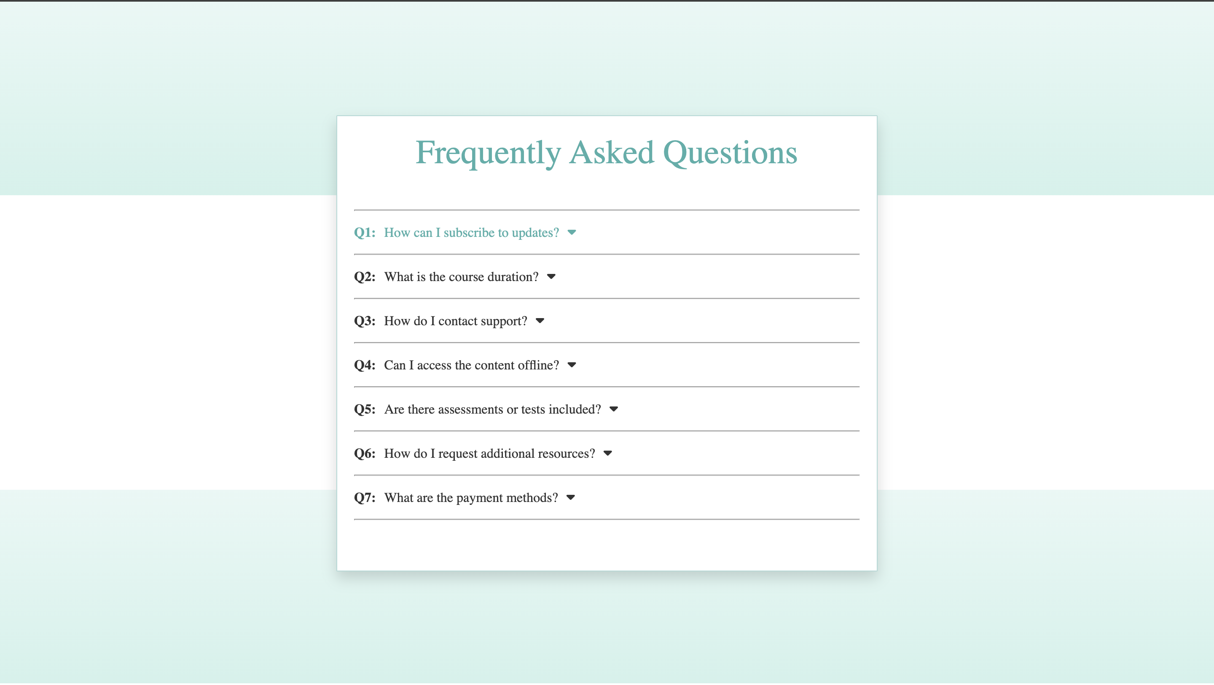

HTML code:

<!DOCTYPE html>

<html lang="en">

<head>

<meta charset="UTF-8">

<meta name="viewport" content="width=device-width, initial-scale=1.0">

<title>FAQs</title>

<link rel="stylesheet" href="faqs.css">

<link rel="stylesheet" href="https://cdnjs.cloudflare.com/ajax/libs/font-awesome/6.5.2/css/all.min.css" integrity="sha512-SnH5WK+bZxgPHs44uWIX+LLJAJ9/2PkPKZ5QiAj6Ta86w+fsb2TkcmfRyVX3pBnMFcV7oQPJkl9QevSCWr3W6A==" crossorigin="anonymous" referrerpolicy="no-referrer" />

</head>

<body>

<div class="main">

<div class="bg">

<div class="one">

</div>

<div class="two">

</div>

</div>

<div class="box">

<div class="head">Frequently Asked Questions</div><br/><br/><hr/>

<p class="p"><b>Q1:</b> How can I subscribe to updates?<i class="fa-solid fa-caret-down"></i></p><hr/>

<p class="p"><b>Q2:</b> What is the course duration?<i class="fa-solid fa-caret-down"></i></p><hr/>

<p class="p"><b>Q3:</b> How do I contact support?<i class="fa-solid fa-caret-down"></i></p><hr/>

<p class="p"><b>Q4:</b> Can I access the content offline?<i class="fa-solid fa-caret-down"></i></p><hr/>

<p class="p"><b>Q5:</b> Are there assessments or tests included?<i class="fa-solid fa-caret-down"></i></p><hr/>

<p class="p"><b>Q6:</b> How do I request additional resources?<i class="fa-solid fa-caret-down"></i></p><hr/>

<p class="p"><b>Q7:</b> What are the payment methods?<i class="fa-solid fa-caret-down"></i></p><hr/>

</div>

</div>

</body>

</html>

CSS code:

body{

margin: 0;

padding: 0;

}

.main{

display: flex;

justify-content: center;

align-items: center;

height: 100vh;

position: relative;

}

.bg{

position: absolute;

width:100%;

height:100%;

z-index:-1;

}

.one {

height: 230px;

background: linear-gradient(to bottom, #e8f8f5, #d1f2eb)

}

.head{

font-size: 40px;

text-align: center;

color:#4CAFAA;

}

.two{

height: 230px;

margin-top: 350px;

background: linear-gradient(to bottom, #e8f8f5, #d1f2eb)

}

.box{

background-color: white;

height: 500px;

width:600px;

padding:20px;

border-width: 1px;

border-style: solid;

border-radius: 1px;

border-color: #aed9d6;

box-shadow: 0 8px 16px rgba(0, 0, 0, 0.15);

color: #333333;

position: relative;

}

.p{

display: flex;

gap:10px;

}

.p:hover{

color:#4CAFAA;

}

h1{

text-align: center;

color: #4CAFAA;

}

**THANK YOU**